TYDD ST MARY
CHURCH OF ENGLAND
PRIMARY SCHOOL

A voyage of opportunity and discovery

TYDD ST MARY CHURCH OF ENGLAND PRIMARY SCHOOL

CONTENTS

Headteacher’s Letter
Visions, Values and Aims
Governors of Tydd St Mary Church of England Primary School
Staff Members
The School Day
Accommodation
Administration and Organisation
Curriculum
Extra Curricular Activities
Special Needs
Pupil Premium Information
Sports Funding
Home and School
Homework
Parents in School
Conduct
Illness at School
Absence
Absence Due to Holidays
Sun Awareness
School Photographer
Parent Teacher Association
School Uniform & Price List
Looking Ahead
School Holidays and Term Dates

Tydd St. Mary Church of England School
Churchway
Tydd St. Mary
Wisbech, Cambridgeshire
PE13 5QY
Tel/ Fax: 01945 420269
Email:enquiries@tydd-st-mary.lincs.sch.uk

Headteacher: Mrs. Sonya Ely BEd Hons NPQH

Dear Parents,

A very warm welcome to Tydd St Mary Church of England Primary School!

Whether your child is just about to start school or is joining us from another school, it is a transition that can make parents and children anxious. Hopefully this prospectus is one of the ways we can help to make that transition as smooth as possible.

In the prospectus you will find useful information about our school, from our vision, values and aims to the practical details that will give you the information you most need. If you have any questions or concerns, at any time, please come and see us.

It is important to us that we work in partnership with all our parents to ensure the best for all the children in our care. Working together we can ensure that your child has a rewarding, fulfilling and happy learning journey at our school, discovering new things and making the most out of all the opportunities offered.

Yours sincerely,

Sonya Ely.
Head Teacher.
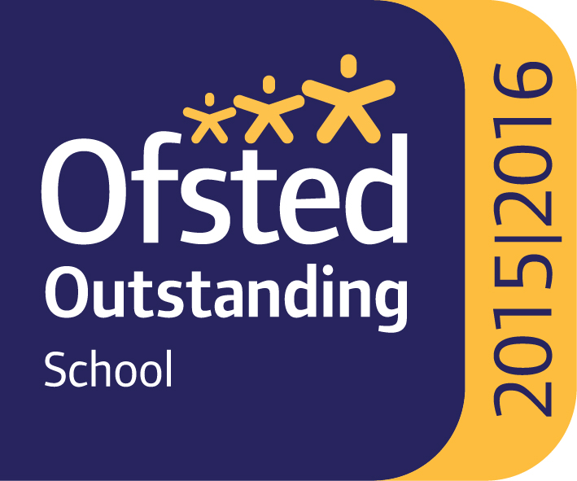
Sharing
Aspirations
Inspiring
A voyage of discovery
and opportunity
Learners

Visions, Values and Aims

Children are the centre of our vision. Through shared aspirations we aim for everyone to meet their greatest potential. We believe in providing opportunities for all to become confident, caring, self-motivated individuals with a passion for learning.

At Tydd St Mary’s we foster a caring environment, promoting consideration and appreciation for others. We spend time developing self esteem, self discipline and independence. As a church school we take pride in developing the spiritual and moral education of children based on basic Christian principles.

Parents are always welcome in school. They are encouraged to discuss openly any concerns and to play an active part in the life of the school. Together we aim to develop the full potential of every child. We are proud of our children and our committed staff provide them with a good education, inspiring learners.

We aim to:
- Create a happy and secure community in which everyone feels valued and respected, with equal opportunities for all.
- Promote positively the spiritual, moral, cultural and social development of all children, always with a sense of pride, purpose and self motivation.
- Help children develop lively, enquiring minds by providing an imaginative, inspiring curriculum so that they can flourish.
- Establish an effective and constructive partnership between home, school and the community.
- Develop an understanding of our Christian foundation.

GOVERNORS OF TYDD ST MARY CHURCH OF ENGLAND PRIMARY SCHOOL

St Mary’s is a Church of England Voluntary Aided School. The Governing Body consists of 10 members representing the Church, County and Local Councils, parents, teachers and staff.

Headteacher Mrs Sonya Ely
Chair of Governors Mr C Browne (Foundation Governor)
Clerk to the Governors Mrs B Hasler
LEA Governor Mr D Maunder (Vice Chair)
Foundation Governors Mr C Browne (Vice Chair)
Rev. David Oxtoby
Mr C Wilson
Mrs L Kirkham
Miss S Hornsby
Ms J Sherry
Teacher Governor Miss V Parker
Parent Governor Mr N Hunt
Mr J Godfrey

Regular meetings are held to discuss the policies necessary to provide an effective and efficient organisation of the school. The Governing Body is supportive of the staff, pupils, parents and wider community working together to provide education of the highest quality.

STAFF MEMBERS

Teaching

Mrs Sonya Ely Headteacher
Mr Mark Spelman Years 5 & 6
Mrs Lucie Burton Years 3 & 4
Miss Hollie Atkin Years 1 & 2
Miss Vikki Parker Reception

Teaching Assistants

Mrs Sylvia Pateman Foundation Stage
Mrs Jan Pope Years 1 & 2
Miss S Hornsby EYFS Years 3& 4
Mrs Paula Van Dyke Years 1 & 2
Mr Steve Ely Years 5 & 6

Non Teaching

Mrs Mary Want Secretary
Mr Steve Ely Caretaker

Midday Supervisors

Mrs Sara Shipley
Mrs Jackie Lambert
Miss Zoe Fagan
Mrs Vanessa Neale

Outside Agencies

Mr Andrew Hardy Educational Psychologist
Hannah Clark Speech and Language Therapist

THE SCHOOL DAY

The school day begins at 9:00am and finishes at 3:00pm for children in the Foundation Stage and Key Stage One and 3:15pm for those in Key Stage Two. In the morning there are members of staff on duty from 8.50am and it is not advisable for children to arrive at school before this time. In bad weather particularly, it is better for the children to arrive as close to 9.00am as possible.

Lunchtime is from 12:00 – 1:00 pm (12:10- 1:00 pm Key Stage Two). Hot lunches are provided daily by Roffes Catering and cost £2:30 and menus are distributed weekly to enable parents to select meals they wish their child/ren to have.

Please be aware that dogs are not allowed on the premises and the whole school is a no-smoking site.

The children wait in the playground until the whistle goes and then make orderly lines before proceeding to their classrooms.

Bicycles can be brought to school and parked in the bicycle shed.



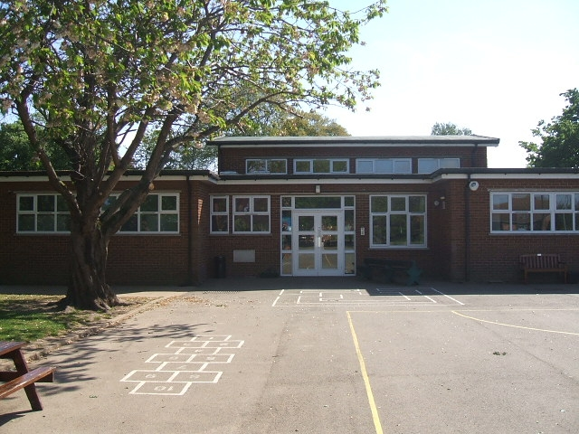
ACCOMMODATION

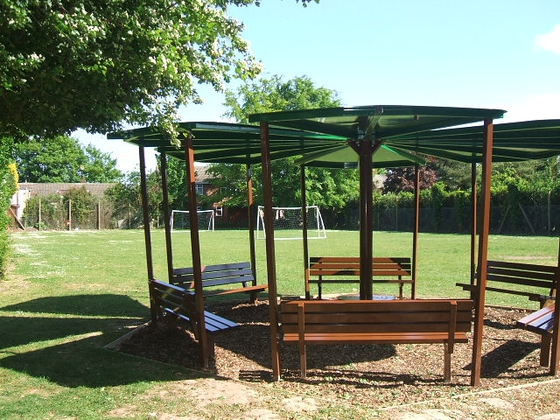
The school is situated in the centre of the village and is housed in a modern building in its own grounds and adjacent to the village playing field. There are three classrooms, a hall, a resources room and an office and we a purpose built Reception Class Unit. There is a play area and a playing field.

Parents are encouraged to use the car park at the back of the school on the playing field, by kind permission of the Parish Council.

ADMINISTRATION AND ORGANISATION

Tydd St Mary is a co-educational Church of England Primary School. Children are admitted into the Reception class in the September in the academic year of their fifth birthday (September 1 – August 31), and leave in the sixth year to progress onto senior school, at the age of 11.
The children are taught in four class groups: Reception, Years 1 & 2, Years 3 & 4 and Years 5 & 6.
If the standard number of 15 for a particular year group is not sufficient to meet the requests of all parents, then the following criteria will be applied (in the rank order shown) to determine how places will be allocated:

- Children in public care
- Children who have a brother or sister at the school
- Proximity of pupil’s home to the school, those living nearest being accorded highest priority.

Details of our admission policy can be found on our school website www.tydd-st-mary.lincs.sch.uk.

CURRICULUM

At Tydd St Mary we provide a lively, challenging curriculum that meets the requirements of the National Curriculum. Our concept of education is based on the individual, as learning is unique for each of us. We make three provisions for learning. These are:

- Class work
- Group activities
- Individual work

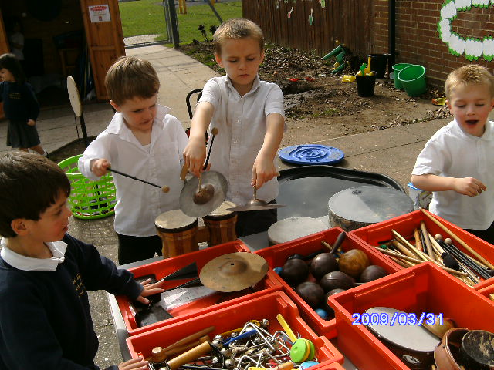
Literacy, Numeracy, Science and ICT are the main core subjects. Great emphasis is placed on these areas and they form the foundation and the framework for the wider curriculum which embraces: Religious Education, History, Geography, Personal Social and Health Education, Physical Education, Dance, Art, Design Technology, Music and Drama and French. There are many opportunities for your child to explore these areas in different ways and at different levels as they progress through the school.

Religious Education is taught throughout the school in accordance with the County Guidelines. It helps children gain a better understanding of Christianity and other faiths. We have close links with St Mary’s Church and all children attend church four times throughout the year and an Act of Collective Worship is carried out each day in school. In all these acts of worship, as in our dealings with one another, the concepts of love, care, respect and tolerance are emphasised.
Parents have the right to withdraw children from R.E and/or Acts of Collective Worship and appropriate supervision will be provided for any child withdrawn.


The children also have swimming lessons at the Hudson Pool in Wisbech in the second half of the summer term. The School contributes towards the cost of this but parents are asked to pay for the cost of the coach.

Throughout the year various visits and visitors are planned into our curriculum to support and enhance the work we do in school.
Further information is available on our website www.tydd-st-mary.lincs.sch.uk
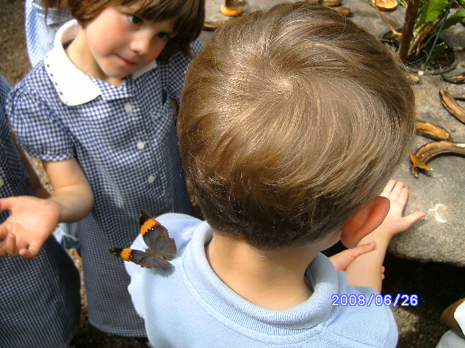
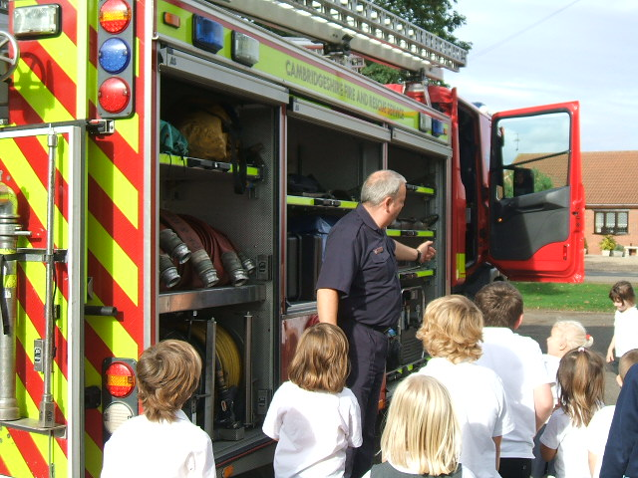


EXTRA CURRICULAR ACTIVITIES



We have a variety of after school activities, some run by members of staff and others by outside agencies where there is a charge (gymnastics for example). Parents will be advised of which activities are being offered each term and to which classes. Parental consent must be gained before any child can participate in any out of school activities. When children stay after school for clubs parents are asked to make satisfactory arrangements for them to be collected promptly when the activity ends. The children will be given advanced warning if for any reason the activity is cancelled.


We are currently offering a Breakfast Club, which is proving very successful. This runs from 8.00am each morning and costs just £1:50. Children are offered a variety of breakfast foods, and they then have the opportunity to join in activities such as playing games until school begins.

We also send home various information regarding other organisations who offer after school care, including activities run through the school holidays.

SPECIAL NEEDS

All children have complete access to the National Curriculum. We strive to differentiate the curriculum to ensure that tasks are well matched to a child’s ability. Systems are in place to identify and assess the needs of all pupils and we have assistants in school who support those children with Special Educational Needs. For some we also seek alternative professional advice. Parents are fully informed and consulted in all aspects of provision for their child.

For our more able children we offer the opportunity for accelerated and challenging additional work including homework, in order to reach their full potential.

Details of our Special Educational Needs Policy can be found on the school website www.tydd-st-mary.lincs.sch.uk

Pupil Premium Information
The government introduced the Pupil Premium, which is additional to main school funding, to address the current underlying inequalities between children eligible for free school meals (FSM) and their peers by ensuring that funding to tackle disadvantage reaches the pupils who need it most.
The Pupil Premium was introduced in April 2011 and is allocated to schools to work with pupils who have been registered for free school meals at any point in the last six years (known as ‘Ever 6 FSM’).
Schools also receive funding for children who have been looked after continuously for more than six months, and children of service personnel.

Principles

At Tydd St Mary Church of England Primary School:

- We ensure that teaching and learning opportunities meet the needs of all of the pupils
- We ensure that appropriate provision is made for pupils who belong to vulnerable groups, this includes ensuring that the needs of socially disadvantaged pupils are adequately assessed and addressed
- In making provision for socially disadvantaged pupils, we recognise that not all pupils who receive free school meals will be socially disadvantaged
- We also recognise that not all pupils who are socially disadvantaged are registered or qualify for free school meals. We reserve the right to allocate the Pupils Premium funding to support any pupil or groups of pupils the school has legitimately identified as being in need of intervention and support
- Pupil Premium funding will be allocated following a needs analysis which will identify priority classes, groups or individuals. However, all classes will have additional adult support every morning. Limited funding and resources means that not all children receiving free school meals will be in receipt of Pupil Premium interventions at one time
The range of provision the school has used the PPG allocation for includes:
- Providing small group work with an experienced teacher/TA focused on overcoming gaps in learning
- The major focus of our work through the pupil premium is aimed at accelerating pupil progress – moving children to at least age related expectations in Literacy, Numeracy and Science.
- Pupil premium resources used to target able children on FSM to achieve L3 at the end of KS1 or L5 at the end of KS2
- 1:1 Tuition
- Whole staff training
- Additional teaching and learning opportunities which have included subsidised day visits.
- Supporting transition arrangements for pupils new to the school with a high mobility rate.

Overview of the School 2015/16
Number of Pupils and Pupil Premium Grant (PPG) Received 2015/16
Total number of pupils on roll (NOR) | 102
Total number of pupils eligible for PPG | 15  15% of the NOR
Amount of PPG received | £21,120
The impact of the PPG for 2015/16 has been:
Pupils have benefitted greatly from the enrichment of the curriculum and from the pastoral support on offer. Improved attendance and punctuality along with improved self esteem and self image have led to clear gains for many of these pupils.
Foundation Stage
1 pupil was in receipt of Pupil Premium and achieved a good level of development in all areas.
Phonics Screen
Of the 15 Y1 pupils taking the screen 0 were in receipt of Pupil Premium. 2 of the pupils taking the screen in Y2 were in receipt of Pupil Premium and met the standard.
End of KS1
3 children were in receipt of Pupil Premium. 1 pupil met age related in reading and targeted support is being given in all other areas to continue to narrow the gap.
End of KS2
1 child in receipt of Pupil Premium achieved age related expectation in Maths and Writing (inc. Grammar, Punctuation and Spelling) making accelerated progress. Expected progress was made in reading.

HOME AND SCHOOL

We believe that contact between home and school is essential for each child’s well being. During the school year there will be opportunities for parents to visit the school informally. Parents’ evenings will be held on a regular basis. If parents have any questions or concerns about their child, socially or academically, class teachers should be contacted in the first instance.

Throughout the year there will be a number of meetings and functions covering different aspects of school life, such as: new parent meetings, open evenings and of course the usual highlights of School Plays and Sports Days.




HOMEWORK

When children have worked hard in school all day, they appreciate a time to relax and spend time with their families. However, we recognise the value of working at home together with parents. In the early years, homework may consist of reading, spelling or numeracy. This increases into longer, more demanding tasks as the children grow older.

PARENTS IN SCHOOL

Parent helpers are most welcome in school. Those working with us at the moment help in a wide variety of ways. If you have some spare time and/or some special interest or skill to offer us please do!
Each week we hold a Parents in Class session for each class at the end of the school day. Parents are invited into work alongside their children on current curriculum targets.

CONDUCT

Strong emphasis is laid on sensible and courteous behaviour at all times. The children are encouraged to behave with care and thought for others.
If for any reason we are concerned about your child’s behaviour at any time you will be invited to discuss it with us. Parental co-operation in this area is especially helpful, and I am sure that our combined efforts can usually produce a swift and significant improvement in the situation.
St Mary’s Code of Conduct
We are gentle, kind and helpful

We listen

We are honest

We work hard

We look after property

WE KNOW THAT WE OWN OUR OWN BEHAVIOUR!

As teachers we are committed to

- Developing each child fully
- Teaching effectively and aiming for the highest standards in both work and conduct.
- The pastoral care of each child.
- Providing regular contact with parents.

We would anticipate the following commitments from parents:

- To show by your example that you support the school and its aims.
- To ensure your child arrives in school on time and fully rested ready to tackle the day of work.
- To take a positive interest in your child’s work and progress.


MEDICATION, ILLNESS OR ACCIDENTS AT SCHOOL

The well being of your child is of great importance to us. Should your child be taken ill or have an accident at school we will contact you. Please make sure we have up to date contact numbers for emergencies. All members of staff have Basic First Aid Certificates. In the event of a minor fall or accident first aid will be carried out in school.
Please do not send your child to school if he/she is at all unwell. A sick child is unable to cope with the rigors of the school day and we do not have the staff or the facilities to give them the care and attention they need. Please note that children are not to return to school until there is a clear 48 hours since the last episode of sickness.
If for any reason your child needs short term medication during the day then you will need to be available to administer it. Children requiring long term treatment for conditions such as asthma or diabetes may bring in medication which will be kept in a secure place until required.
Any allergies your child has must be shared with staff so that we are fully aware and prepared.

ABSENCE

If a child is absent at any time it is essential that the school be notified by telephone and a letter as soon as possible. Early warning of infectious diseases is especially helpful. If we do not receive notification of why a child is not in school by 9:30 we operate ‘First Day Calling’ and will contact you to determine why your child is absent. Cases of persistent lateness and unexplained absences will be referred to the Educational Welfare Officer.

ABSENCE DUE TO HOLIDAYS

The law states that children may be granted leave of absence in certain exceptional circumstances. However, the reasons for the leave of absence must be exceptional for this absence to be authorised. All request forms should be completed prior to the leave being booked and are available from the school office. Any absence unless deemed exceptional will be unauthorised, and may be noted by the Educational Welfare Officer resulting in Fixed Term Penalty Notices being issued. Our Regular school attendance is very important. Children can lose confidence and become apprehensive if they miss work and the pattern of the school routine is interrupted. Our Attendance Policy is available via the school website www.tydd-st-mary.lincs.sch.uk


SUN AWARENESS

We encourage children to wear clothing which covers the skin and protects from the sun, including hats. Please do not send children in sundresses. An application of sun cream in the morning before your child comes to school should be sufficient to see them through the day.

SCHOOL PHOTOGRAPHER

A photographer usually visits the school in the autumn term. Parents with younger children are invited to bring them along so that family groups can be photographed.


PARENT TEACHER ASSOCIATION

We are very proud of the Parent Teacher Association. Members of this voluntary group raise funds throughout the year by arranging events. This money is then used to support the children and school in a variety of ways, eg. paying for swimming lessons at the Hudson Pool, paying for the children to attend the annual pantomime, not to mention the valuable contribution to the range of equipment that the children use regularly – computers, play equipment etc. Regular newsletters are sent out by the committee and all parents are most welcome to join the Association, please do not hesitate to ask for further information.

SCHOOL UNIFORM
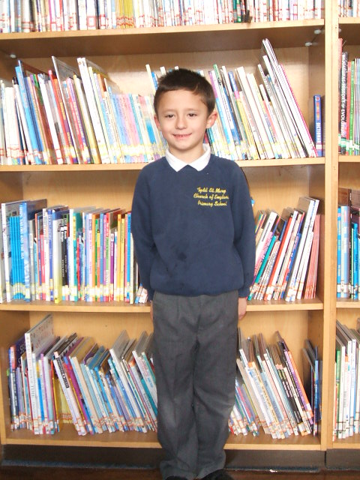
Boys

Grey or navy trousers/shorts in summer
White or blue polo shirt or shirt
Navy blue sweatshirt with logo
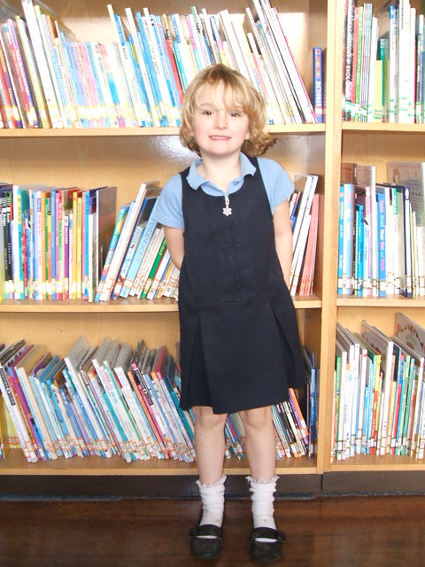
Navy blue or grey jumper

Girls

Grey or navy blue skirt or tunic – pale blue striped/checked dress in summer
White or blue polo shirt or shirt
Navy blue sweatshirt with logo
Navy blue or grey jumper/cardigan

Sweatshirts, polo shirts and book bags with the school logo can be purchased from the school office.

Sensible shoes and boots with no high heels. Jewellery may not be worn in school except for one pair of ear studs, which must be taped or removed for PE and handed to a member of staff for safe keeping. No make up including nail varnish to be worn in school.

PE KIT

Shorts
T-shirts
plimsolls
tracksuit for outdoor PE
swimming costume/trunks

PLEASE MAKE SURE ALL ITEMS OF CLOTHING ARE NAMED!!

The Caretaker keeps all lost property and all enquiries should initially be made to him.

LOOKING AHEAD

At the age of 11, children transfer to secondary schools. Children from this school can transfer to Spalding High School for Girls, or Spalding Grammar School for boys, if they meet the current 11 plus examination requirements. Other schools to which children transfer include: The Peele Community College, Long Sutton; The George Farmer School, Holbeach; Gleed School for Boys and Gleed School for Girls, Spalding; and the Thomas Clarkson Community College in Wisbech.
There is also the Wisbech Grammar School, which is an independent fee-paying school. All relevant information is sent to parents in the year of transfer.



